TASK 1

1.WRITE A PROGRAM THAT CHECKS EVEN AND ODD NUMBER..

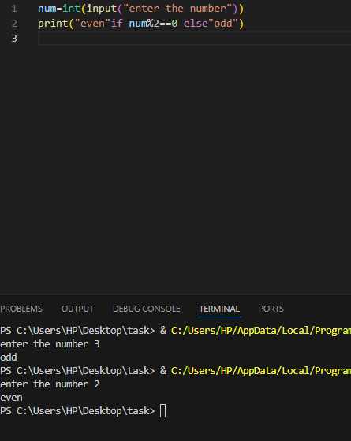

2.WHAT IS THE OUTPUT OF THE FOLLOWING EXPREESION ?

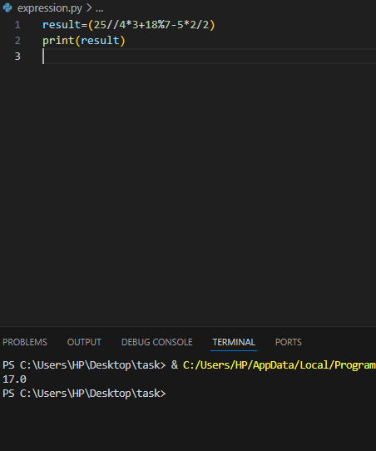

3.WRITE A PROGRAM BY USING THE MODULUS OPERATOR..

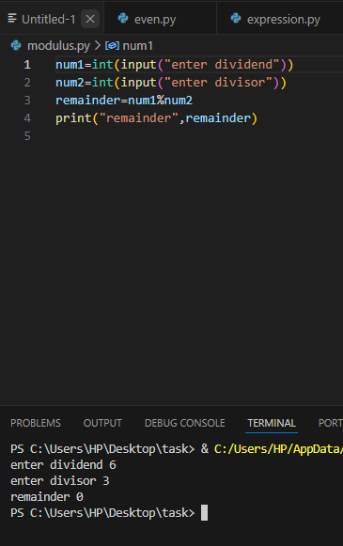

4.WRITE A PROGRAM TO CALCULATE THE AREA OF TRIANGLE ..

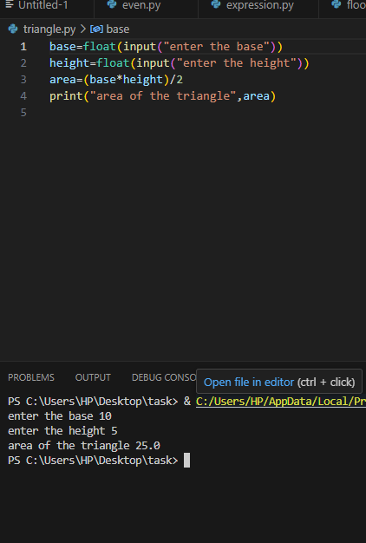

5.WRITE A PROGRAM TO CALCULATE THE AREA OF RECTANGALE ..

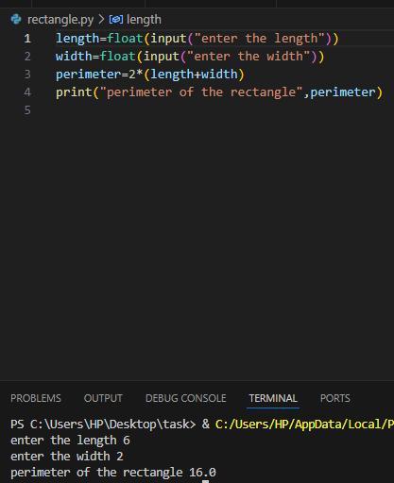

6.WRITE A PROGRAM TO PRINT THE GRADE ..

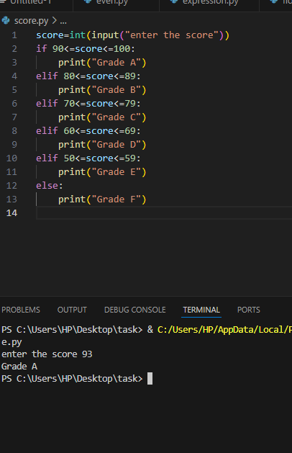

7.WRITE A PROGRAM TO SEE THE NUMBER IS GREATER,SMALLER,EQUAL ..

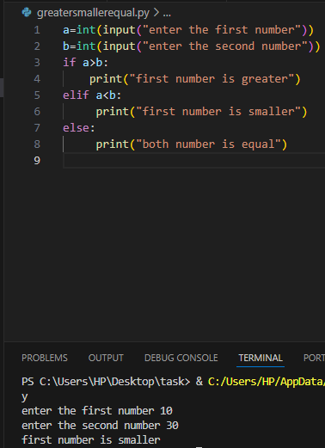

8.WRITE A PROGRAM TO SEE THE NUMBER IS POSITIVE,NEGATIVE OR ZERO ..

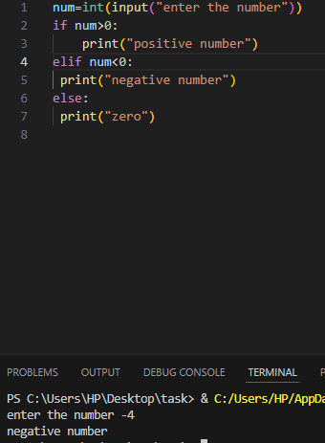

9.WRITE A PROGRAM TO SEE THE LARGEST OF TWO NUMBER..

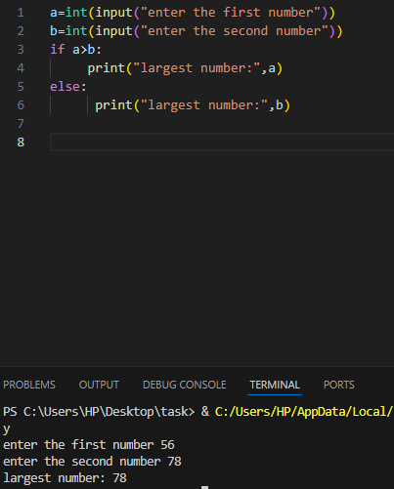

10.WRITE A PROGRAM TO PERFORMS THE FLOOR DIVISION AND MODULO OPERATIONS..

